***LEAF-Louisiana Elite Advocacy Force Mini Fact Sheet***

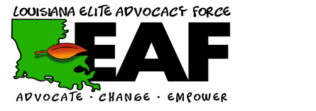

1. LEAF was formed in 2019 as a re-designed version of LYLAC. It is the official Louisiana State Advisory Board.
2. LEAF prides itself in enforcing the Mission at the forefront of all work; Advocate with current and former foster youth to unite voices, and Change policies, laws, and perceptions in order to Empower youth to become leaders and reach their full potential.
3. The vision is A world/community where every child has the right to safety, a loving home, permanency and overall well-being in which they can build a successful future.
4. LEAF tagline Utilizing negative experiences to facilitate positive changes for foster youth
5. LEAF’s leaders are executive members consist of President, Vice President, Secretary, Communications Officer, Parliamentarian, Treasurer, and Peer Mentor. They help in ensuring the daily operations of the board.
6. LEAF members stay connected through monthly meetings (which are virtual right now), quarterly retreats held every three months (different places throughout the state s/a Baton Rouge, etc.) They also check in through workdays where they make plans for how they will continue to advocate and changes they can assist in making
7. LEAF has several community partners but some of the major ones are James Samaritan and The Pelican Center (where they are currently working to improve courtroom practices, increase youth voice in the courtroom, and implement a state-wide legal representation survey for youth and attorneys.
8. LEAF tackles all these tasks by splitting work into 3 main subcommittees—Placement Stability/Media, State Board Structure, and Policy where members meet monthly.
9. LEAF also work to tackle ‘hot topic’ child welfare issues and needed improvements by speaking on panels, at trainings, and even at conferences throughout the state.
10. LEAF members also present testimony on important child welfare related bills at the state level both in the Senate and House of Representatives at the Louisiana Capitol.
11. One of the most recent accomplishments of LEAF was writing and passing the first ever Foster Youth Bill of rights which was signed into law on June 16th,2021, and it outlines the rights that ALL youth in foster care should have while in the system.
12. We accept applications about 3 times a year, in Jan., May, Sept., You must be age 18 or older to apply and demonstrate leadership and maturity. Members do receive compensation for their time and work on the board.
13. We hold elections every year in July at our annual summer retreat.